**Medical Diagnosis Agent**

**KAUSHAL SHAH**

**2021229618**

**kbs140130**

**Problem Description:**

There are certain common diseases for which every patient has to go the doctor. With the help of this diagnosis agent, the patients will not have to go the doctor. They just need to input their symptoms and they can know what disease they suffer from. This saves time for them as well as for the doctors who can spend their time on more complicated cases.

**Proposed Solution:**

The patients need to input their symptoms to the system and the system uses facts stored in the knowledge base to infer the disease that the patients suffer from. If the patients do not know the medical name of the symptom, they can just enter their body conditions like temperature greater than 98.5 Fahrenheit. The system using inference will come to know that the patient suffers from fever. This saves the valuable time of patients and doctors as well.

**Implementation Details:**

**Examples:**

The patient inputs three symptoms from the list of symptoms displayed. Example if the patient inputs:

Fever

Cough

Hiccups

The system then asks if the patient has diabetes or not. If the patient says yes, the output is cholera.

If the patient does not have diabetes, the output is jaundice.

There are some diseases that cannot occur along with diabetes and hence diabetes becomes an important parameter and hence is asked for separately.

The patient can also input body temperature 101F. The system using approximation infers that the patient has fever.

The patient can also input blood pressure 120. The system using approximation infers that the patient has vertigo.

**Technique used for detection:**

The knowledge base is created in protégé in the RDF format. There are classes for disorders and symptoms in the knowledge base. Instances of these classes are created and initialized with data as well as object properties. The symptoms in the knowledge base are converted into nodes. The information in the knowledge base is retrieved using SPARQL queries. A graph containing all the symptoms and disorders is created at runtime in java and the appropriate edges are inserted. Now, the system can perform search on the graph based on the user input. The user input becomes the initial state of the search. The search algorithm used is greedy best first search. Two heuristics are used for the greedy best first search. If the patient has diabetes heuristic 1 is used. If the patient does not have diabetes heuristic 2 is used. The heuristics are hard coded in the system.

**Programming Tools:**

Eclipse IDE for Java

Protégé for knowledge base development

Apache Jena API for importing knowledge base in java.

SPARQL for querying the knowledge base.

**Architectural Diagram:**

User Input

Text

Knowledge Base

RDF in Protégé

Output

Inference Engine

Search Engine

Best First Search

The patients input symptoms in plain text. They are matched with the nodes of the graph created at runtime. The knowledge base is created in Protégé in the RDF format. The search engine finds out the disease that the patient suffers from. If the search engine cannot find, the inference engine is called upon.

**Result:**

**Knowledge base snapshot:**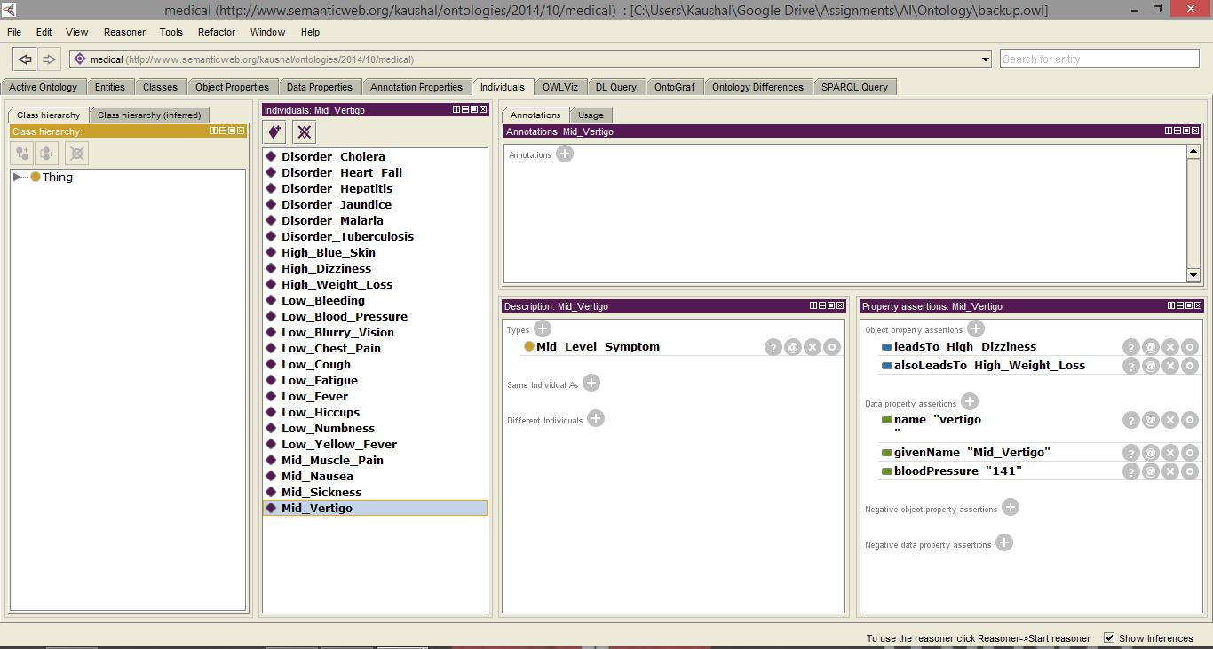

**Java Application Snapshot**

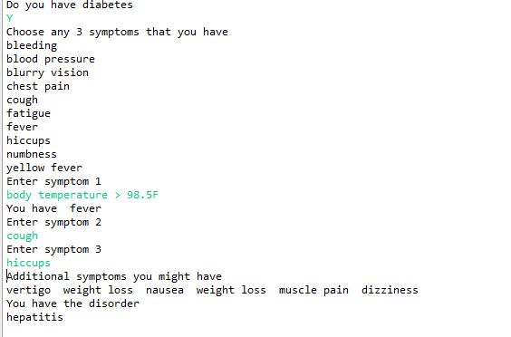

The search path is displayed at the end in the form of additional symptoms. There might be some repetitions in the search path as certain symptoms lead to the same other symptoms.

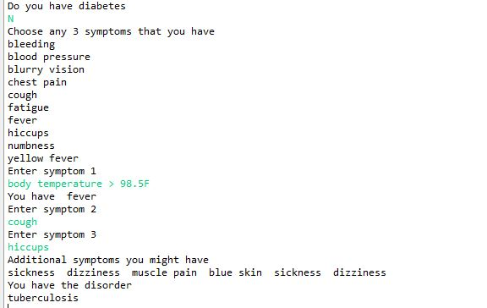

Different result and search path when patient does not have diabetes

**Pending Issues:**

The knowledge base needs to be expanded to include more symptoms and diseases. Also, the patient’s history has to be recorded and taken into consideration while performing search. It will help add more semantic meaning to the project.

**Problems Encountered:**

Importing the knowledge base and converting it into a graph was a major problem in the project. Apache Jena API methods were helpful and the problem was resolved. SPARQL query language was used to retrieve objects from knowledge base.

**Potential Improvements:**

A track can be kept for which disease is caused by which symptoms, that way the agent will not have to search every time and can refer the knowledge base if there was such a case previously.

Also, allergies of patients can be taken into account and then the appropriate medicine should be suggested.